Fabrication and Integration Process

1. Material Choice Justification :
Chose to 3d print ours because we needed movable joints, like shaking hands, moving head, and wag-able tail

2. Fabrication Steps :
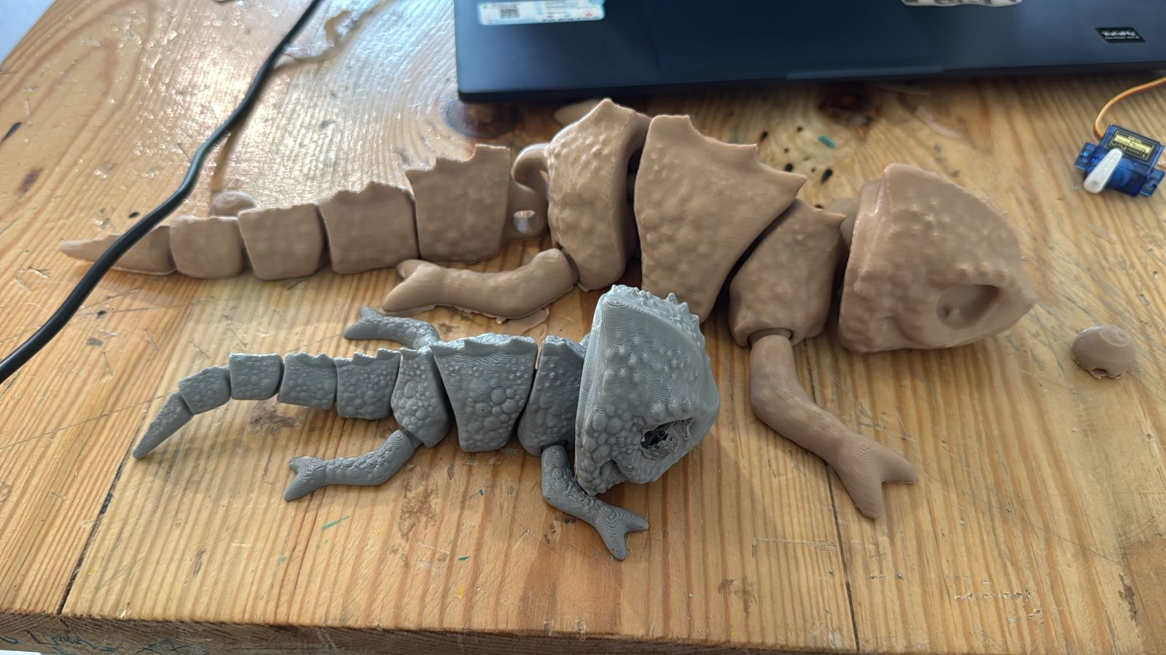
- Get our model 3d printed (success at Sai’s 3rd attempt )
- Fixed it a little bit
- Broke our model into 3 parts - head, body and tail
- Soldered for smooth surfacing
- Tried all 3 parts separately with its respective components, head and servo, tail and servo, touch glued to the hand etc
- Used foamboard and hollowed it out to fit our breadboard
- Made holes to seep wires out from inside (hence, easy to work with foam board)

